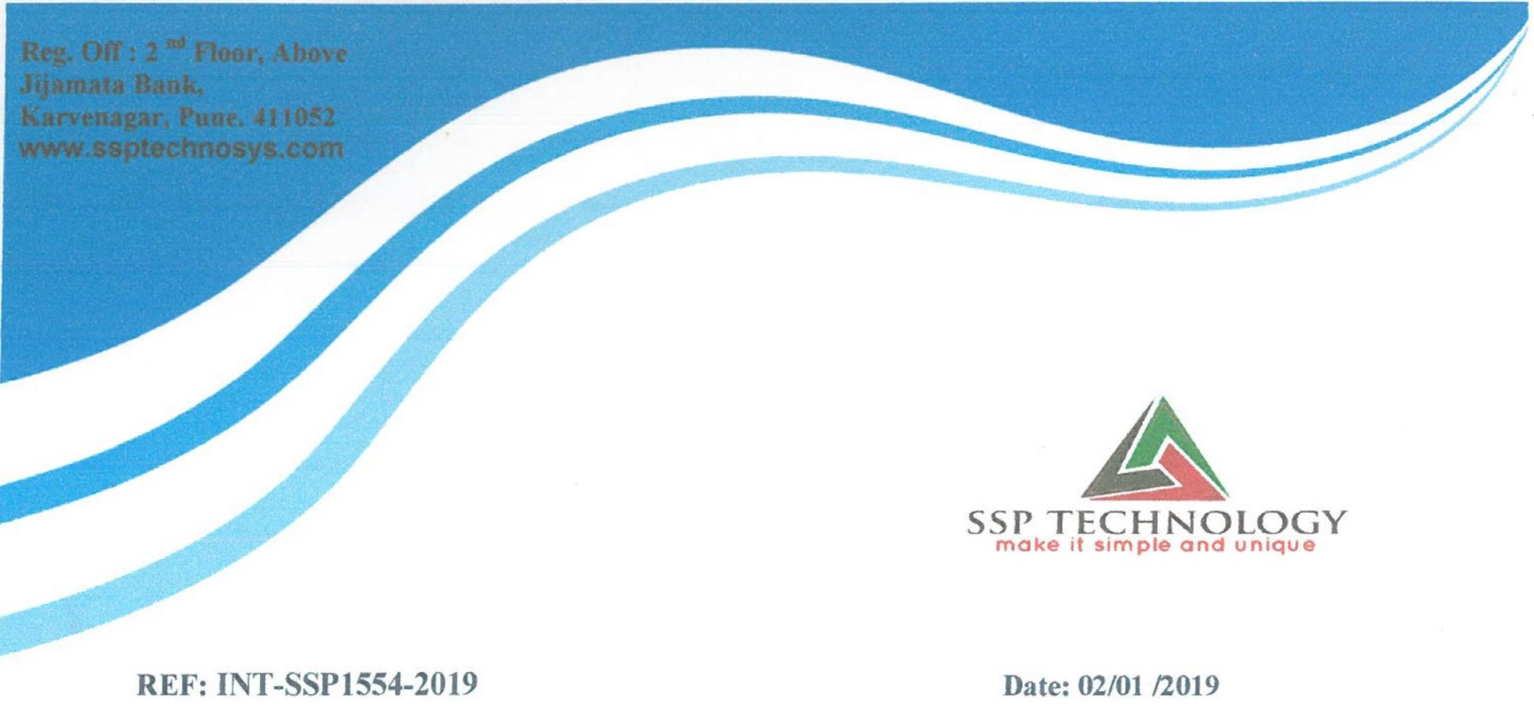

This is to certify that **Mr. Omkar Arun Surve** is undergoing industrial training

at SSP technology Pune under theguidance of **Mrs. Priyanka Marathe.**

Project Title: Noukri Hub

Duration: 9th Jan 2019 to 10th April 2019

